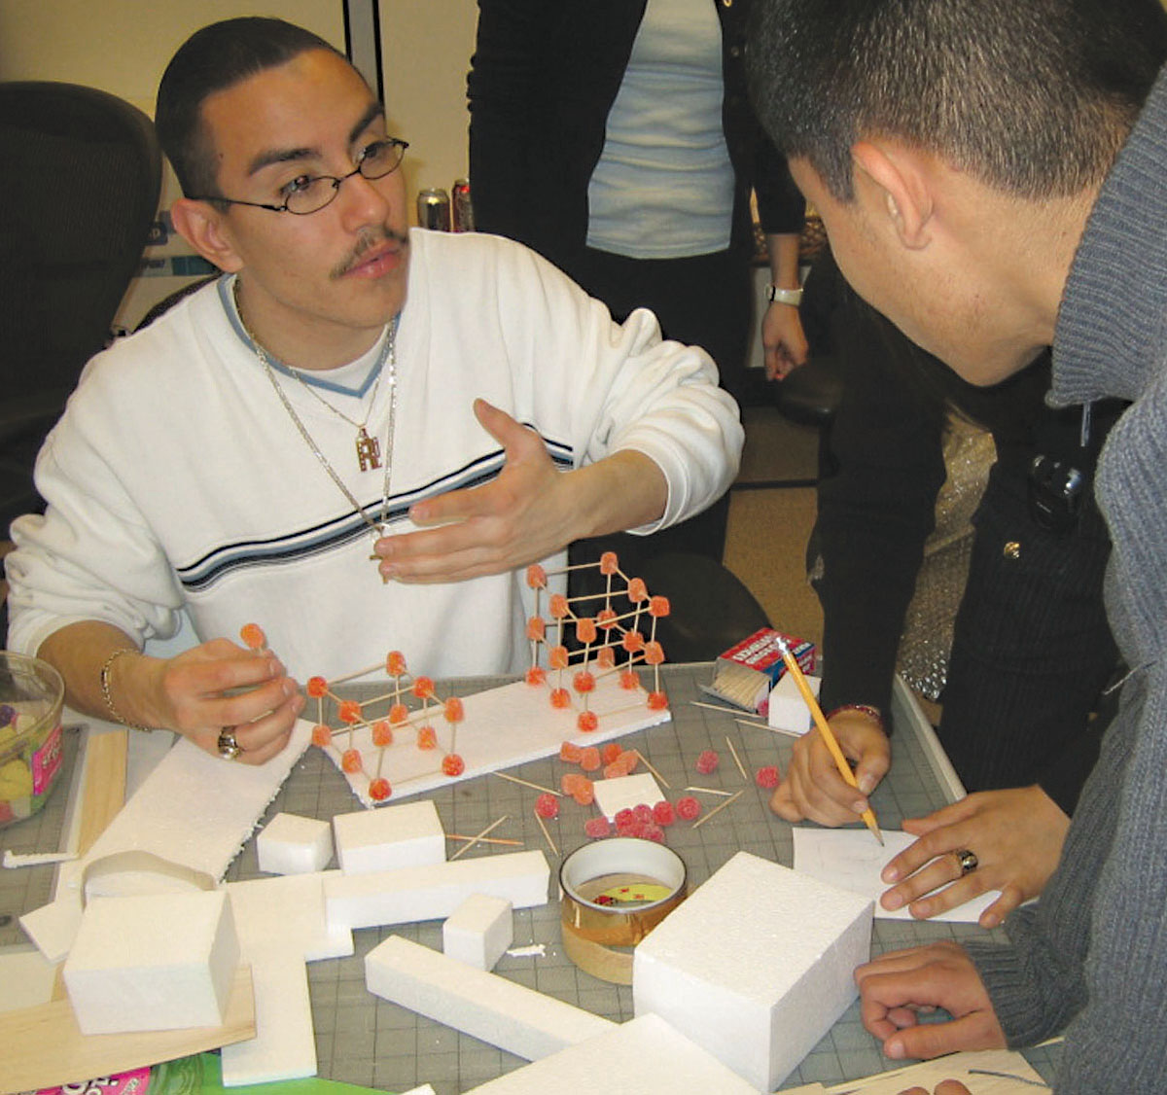

Special Event Invitation

Location and Date

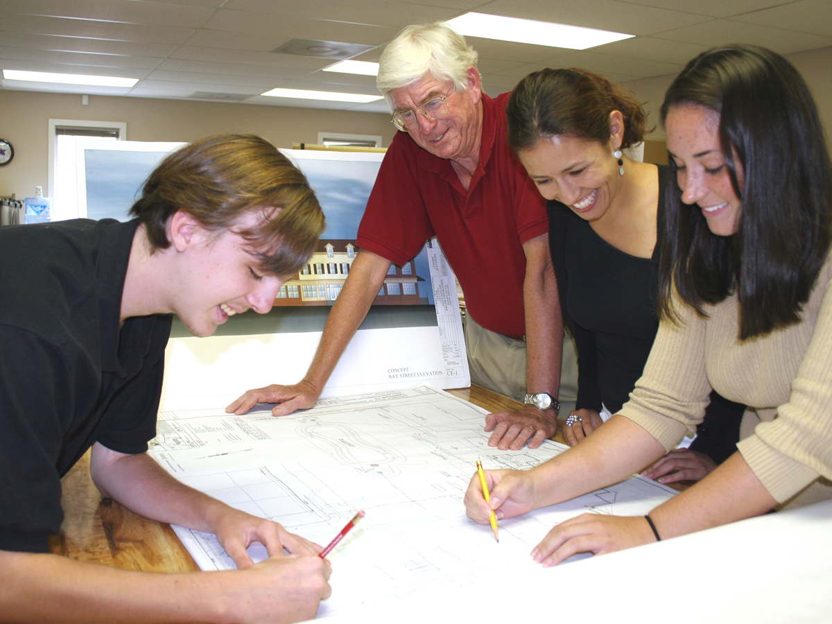

Your Address, City, State 00000 voice fax email

www.acementor.org

Affiliate Name Here

Honorary Chair

Name

**Host**

**Committee**

Name

Name

Name

Name

Name

Name

Name

Name

Name

Name

Name

Name

Name

Name

Name

Name

Name

Name

Name

Name

Name

Name

Name

Name

Name

Name

Name

Name

Name

Name

Name

Name

Name

Name

Name

Name

Name

Name

Name

Name

**Executive Director**

Name

### Career Directions for Students in

**Architecture, Construction and Engineering**

# Please join the ACE Mentor Program as we pay tribute to the contribution of our mentors, celebrate accomplishments of our students, and envision our future work.

Location and Date

##### TITLE

Percilit vel del dignit, quis aliquis am, veraessi. Ecte dolorem digna autat. To dolore esed tio et, quis aut alis essi. Idunt eliquat. Giamcommy nis autem dolor tin utpat. Duismod ex euguerit, quat adigna feu feu facipsum vullan volore velit luptatum eum irit luptat, quisl ipit lobor alisit eugiatue essequatis dit landre magna consecte dit lore dolorer iusting er irit illut iure commy num dunt am ip el ullamcoZ

##### TITLE

Percilit vel del dignit, quis aliquis am, veraessi. Ecte dolorem digna autat. To dolore esed tio et, quis aut alis essi. Idunt eliquat. Giamcommy nis autem dolor tin utpat. Duismod ex euguerit, quat adigna feu feu facipsum vullan volore velit luptatum eum irit luptat, quisl ipit lobor alisit eugiatue essequatis dit landre magna consecte dit lore dolorer iusting er irit illut iure commy alit nim velese eriure modiamcom my non fac Dunt at dionum

##### TITLE

To dolore esed tio et, quis aut alis essi. Idunt eliquat. Giamcommy nis autem dolor tin utpat. Duismod ex euguerit, quat adigna feu feu facipsum vullan volore velit luptatum eum irit luptat, quisl ipit lobor alisit eugiatue essequatis dit landre magna consecte dit lore dolorer iusting er irit illut To dolore esed tio et, quis aut alis essi. Idunt eliquat. Giamcommy nis autem dolor tin utpat. Duismod ex euguerit, quat adigna feu feu facipsum Percilit vel del dignit, quis aliquis am, veraessi. Ecte dolorem