Board of Directors

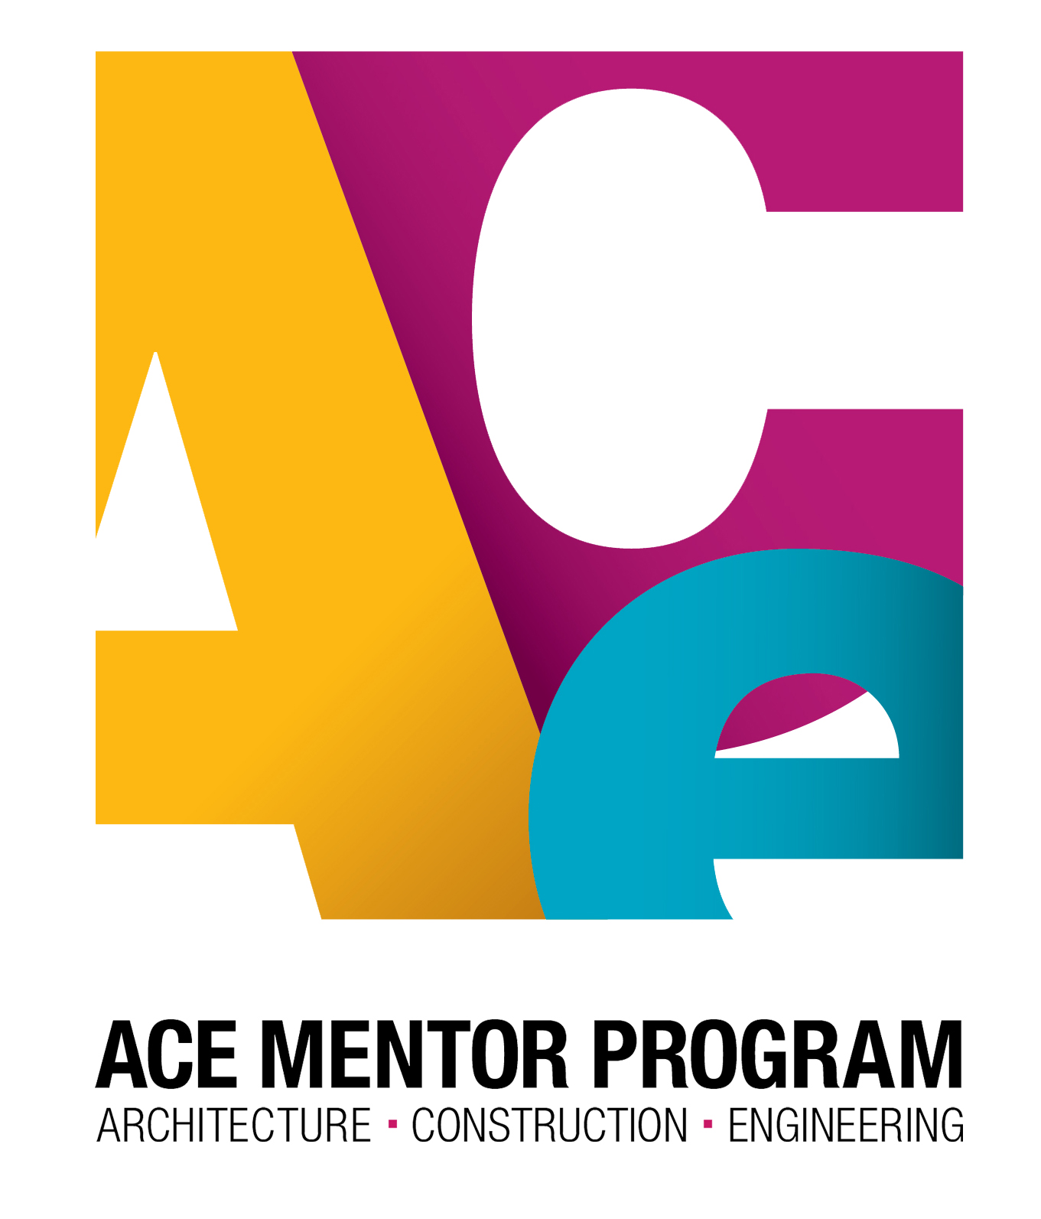

www.acementor.org

Program Name

Location and Date

Affiliate Name Here

Sponsors

### Career Directions for Students in

**Architecture, Construction and Engineering**

Name

Name

Name

Name

Name

Name

Name

Name

Name

Name

Name

Name

Name

Name

Name

Name

Name

Name

Name

Name

Name

Name

Name

Name

Name

Name

Name

Name

Name

Name

Name

Name

Name

Name

Name

Name

Name

Name

Name

Name

Name

Name

Name

Name

Name

Name

Name

Name

RECIPENT

Recipient name here

Recipient name here

Recipient name here

Recipient name here

Recipient name here

Recipient name here

Recipient name here

Name

______________________________________________________WELCOME

Name

______________________________________________________  
INTRODUCTIONS

Name

______________________________________________________PRESENTATION OF ACE ACHIEVEMENT IN EDUCATION

Name

______________________________________________________ACCEPTANCE

Name

______________________________________________________PRESENTATION OF ACE ACHIEVEMENT IN INDUSTRY

Name

______________________________________________________PRESENTATION OF ACE ACHIEVEMENT IN GOVERNMENT

Name

______________________________________________________ACCEPTANCE

Name

______________________________________________________

PRESENTATION OF ACE “Above & Beyond” AWARD

Name

______________________________________________________ACCEPTANCE

Name

______________________________________________________STUDENT PRESENTATIONS

Name

______________________________________________________PRESENTATION OF SCHOLARSHIP AWARDS

Name

______________________________________________________CLOSING

Name

Mentor name here

Mentor name here

Mentor name here

Mentor name here

Mentor name here

Mentor name here

Mentor name here

Name

AWARD

Award name here

Award name here

Award name here

Award name here

Award name here

Award name here

Award name here

Name

Mentors

Scholarship Awards

Program