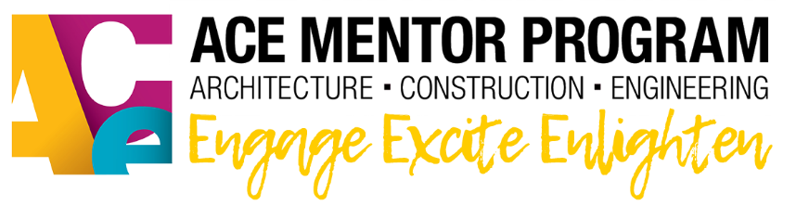

ACE San Diego Alumni Scholarship Form

ACE Mentor San Diego Alumni Scholarships (up to $5000) are available for the following students:

• They are former ACE Mentor San Diego students with a record in ACE national database

• They are enrolled and active at a four year institution in a major leading to a degree in one of the ACE related fields (listed in the ACE San Diego Scholarship Rules)

• They have attained the status of at least equivalent to a third year student with a minimum of 70-72 units upon completion of their 2nd year

• They have maintained a minimum of a 3.0 GPA in college

• They have completed this application, provided the documents in Section III and can demonstrate the need for additional scholarship funding

SECTION I: Contact Information

Last: _______________________First: ____________________Middle Initial:_______
Address: ______________________________________________________________
City: _________________________________ State: _____________ Zip:__________
Phone: ______________________________ Email: ___________________________

SECTION II: Proof of Enrollment
Current College or University: ______________________________________________
Program of Study: ________________________________ Length of Program: ___ yrs
Program Courses You Plan to Complete:
__________________________________ _________________________________
__________________________________ _________________________________
__________________________________ _________________________________
SECTION III: Undergraduate Scholarship Information - Email following items with application
● An official college/university transcript.
● Proof of enrollment from your school for the upcoming semester/quarter.
● Attach a 300-500 word essay that outlines your current need for additional financial support
during the third and/or fourth year of your program of study.
● Attach a 300-500 word essay describing how your experience with ACE San Diego prepared
you for college or how you plan to use your degree in an ACE-related profession.

