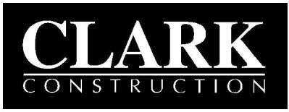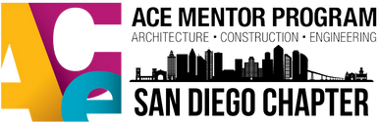
Clark Construction Group AND ACE Mentor San Diego Chapter
VISITOR RELEASE WAIVER AND INDEMNIFICATION

EVENT DETAILS: Trades Day Event DATE: March 18, 2022
LOCATION: SDSU Snapdragon Stadium TIME: 11:00 a.m. – 4:00 p.m.
DESCRIPTION: Students will rotate through various work stations in order to experience carpentry, concrete, electrical, plumbing, steel and other construction work via hands-on learning activities.
I, the undersigned, in full recognition and appreciation of the dangers and hazards inherent in visiting a construction site, freely acknowledge and understand that the activity involves the risk of serious bodily injury or death, and I fully accept and assume all risks and responsibility for injuries, losses, liabilities, damages and costs which I may incur as a result of my participation in the activity. I have been advised that I must wear a hard hat, safety glasses with side shields and any other personal protective equipment as may be required by Clark Construction Group – CA, LP at all times while on the construction site. I, on my behalf and on behalf of my personal representatives, executors and heirs, hereby release and agree to indemnify, defend and hold harmless Clark Construction Group – CA, LP, San Diego State University, its affiliates, partners (including joint venture partners), subsidiaries, related companies, members, managers, officers, directors, agents, employees or volunteers, subcontractors and sub-subcontractors, and if applicable, the owner(s) or lessor(s) of the property (“Releasees”), from and against any and all injuries, losses or liabilities, to the fullest extent permitted by law, incident to my involvement or participation in visiting the construction site (“Release and Indemnification”). This Release and Indemnification shall include, but not be limited to, all injuries, losses or liabilities of any kind whatsoever incurred or sustained by me or my property as a result of the negligence of the Releasees. I acknowledge that I have been given adequate opportunity to read this Release and Indemnification and I am knowingly and voluntarily signing a legal contract waiving certain rights. If any portion of this Release and Indemnification is found to be unenforceable or invalid, that portion shall be severed, and the remainder shall remain in full force and effect.

STUDENT AGREEMENT: I, , understand that certain risks are involved in visiting a construction work site, and I accordingly agree to behave properly and to comply with safety rules and any other directives given to me at the work site by ACE mentors or representatives of the contractor leading the activity. Further, I agree to wear any required clothing such as my own hard-toe shoes or to wear helmets at the event.

SIGNATURE OF STUDENT:
X
Signature of Student Date

PARENT/GUARDIAN CONSENT FORM: In order for your child to participate, this form must be filled out, signed, and returned to your child’s ACE team mentors before the event begins: I hereby give consent for my child,
, , to participate in the above event.I understand that he/she will be accompanied by mentors from the ACE Mentor Program. In consideration of the permission granted to my child by The ACE Mentor Program to participate in the event indicated above, I hereby agree, to the fullest extent permitted by law, to hold harmless, defend, and indemnify The ACE Mentor Program from any and all claims, suits, demands, damages, losses, judgments, payments, awards, and expenses (including reasonable attorney’s fees and costs) that may arise in connection with this event.
SIGNATURE OF PARENT OR GUARDIAN:

X
Signature of Parent or Guardian Print Name Date

Emergency Contact No.:

