10:30 - 11:15 am Shuttle pick-up from Fashion Valley Mall 11:15 - 11:30 pm Student sign-in and safety gear distribution 11:30 - 12:15 pm Lunch and event announcements
12:15 - 12:30 pm Walk to Trades Day station area

12:30 - 12:50 pm Station #1

PLUMBING

12:50 - 1:00 pm Transition and next station instructions

1:00 - 1:20 pm Station #2

ELECTRIC

1:20 - 1:30 pm Transition and next station instructions

1:30 - 1:50 pm Station #3

HVAC

1:50 - 2:00 pm Transition and next station instructions

2:00 - 2:20 pm Station #4

CARPENTRY & CONCRETE

2:20 - 2:30 pm Transition and next station instructions

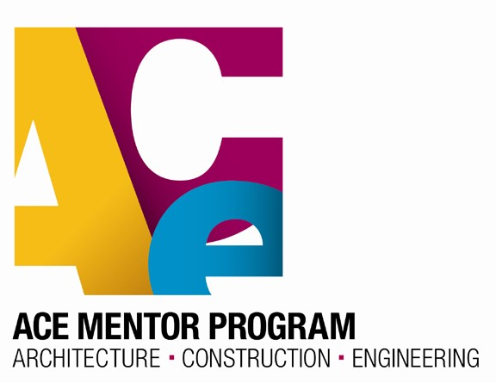
2:30 - 2:50 pm Station #5

DRYWALL

10:30 - 11:15 am Shuttle pick-up from Fashion Valley Mall 11:15 - 11:30 pm Student sign-in and safety gear distribution 11:30 - 12:15 pm Lunch and event announcements
12:15 - 12:30 pm Walk to Trades Day station area

12:30 - 12:50 pm Station #1

TOUR

12:50 - 1:00 pm Transition and next station instructions

1:00 - 1:20 pm Station #2

PLUMBING

1:20 - 1:30 pm Transition and next station instructions

1:30 - 1:50 pm Station #3

ELECTRIC

1:50 - 2:00 pm Transition and next station instructions

2:00 - 2:20 pm Station #4

HVAC

2:20 - 2:30 pm Transition and next station instructions

2:30 - 2:50 pm Station #5

CARPENTRY & CONCRETE

10:30 - 11:15 am Shuttle pick-up from Fashion Valley Mall 11:15 - 11:30 pm Student sign-in and safety gear distribution 11:30 - 12:15 pm Lunch and event announcements
12:15 - 12:30 pm Walk to Trades Day station area

12:30 - 12:50 pm Station #1

DRYWALL

12:50 - 1:00 pm Transition and next station instructions

1:00 - 1:20 pm Station #2

TOUR

1:20 - 1:30 pm Transition and next station instructions

1:30 - 1:50 pm Station #3

PLUMBING

1:50 - 2:00 pm Transition and next station instructions

2:00 - 2:20 pm Station #4

ELECTRIC

2:20 - 2:30 pm Transition and next station instructions

2:30 - 2:50 pm Station #5

HVAC

10:30 - 11:15 am Shuttle pick-up from Fashion Valley Mall 11:15 - 11:30 pm Student sign-in and safety gear distribution 11:30 - 12:15 pm Lunch and event announcements
12:15 - 12:30 pm Walk to Trades Day station area

12:30 - 12:50 pm Station #1

CARPENTRY & CONCRETE

12:50 - 1:00 pm Transition and next station instructions

1:00 - 1:20 pm Station #2

DRYWALL

1:20 - 1:30 pm Transition and next station instructions

1:30 - 1:50 pm Station #3

TOUR

1:50 - 2:00 pm Transition and next station instructions

2:00 - 2:20 pm Station #4

PLUMBING

2:20 - 2:30 pm Transition and next station instructions

2:30 - 2:50 pm Station #5

ELECTRIC

2:50 - 3:00 pm Transition and next station instructions

3:00 - 3:20 pm Station #6

HVAC

10:30 - 11:15 am Shuttle pick-up from Fashion Valley Mall 11:15 - 11:30 pm Student sign-in and safety gear distribution 11:30 - 12:15 pm Lunch and event announcements
12:15 - 12:30 pm Walk to Trades Day station area

12:30 - 12:50 pm Station #1

HVAC

12:50 - 1:00 pm Transition and next station instructions

1:00 - 1:20 pm Station #2

CARPENTRY & CONCRETE

1:20 - 1:30 pm Transition and next station instructions

1:30 - 1:50 pm Station #3

DRYWALL

1:50 - 2:00 pm Transition and next station instructions

2:00 - 2:20 pm Station #4

TOUR

2:20 - 2:30 pm Transition and next station instructions

2:30 - 2:50 pm Station #5

PLUMBING

2:50 - 3:00 pm Transition and next station instructions

3:00 - 3:20 pm Station #6

ELECTRIC

10:30 - 11:15 am Shuttle pick-up from Fashion Valley Mall 11:15 - 11:30 pm Student sign-in and safety gear distribution 11:30 - 12:15 pm Lunch and event announcements
12:15 - 12:30 pm Walk to Trades Day station area

12:30 - 12:50 pm Station #1

ELECTRIC

12:50 - 1:00 pm Transition and next station instructions

1:00 - 1:20 pm Station #2

HVAC

1:20 - 1:30 pm Transition and next station instructions

1:30 - 1:50 pm Station #3

CARPENTRY & CONCRETE

1:50 - 2:00 pm Transition and next station instructions

2:00 - 2:20 pm Station #4

DRYWALL

2:20 - 2:30 pm Transition and next station instructions

2:30 - 2:50 pm Station #5

TOUR

2:50 - 3:00 pm Transition and next station instructions

3:00 - 3:20 pm Station #6
PLUMBING

