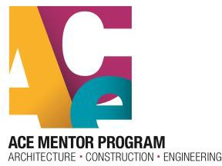

Dear ________________________________________:

We thank you for being one of ____ schools in _________ County involved in this important and formative after-school program. To better communicate what we are doing and what we expect of our ‘partners’, we put together this general overview. Please feel free to reach out with questions, issues and ideas. We want to work with your staff to make this a success for everyone.

For the success of the program, each school needs to identify the 'ACE School Champion' to be our main source of contact and interaction for your school. This person would need to be engaged in the group to the extent that they are the advocate/liaison between the club and the school administration.

- Work to recruit students and assist in getting interested students registered in the ACE database. Assist in getting completed parent consent forms for students.
- Be present and involved during the ACE meeting. The mentors will lead the class, so no teaching or instruction is needed - just being there for the group.
- Assist announcements of field trips and collection of permission slips.
- Help navigate the students through the scholarship application process, helping to get them in touch with the proper counselors and staff to obtain transcripts, letters of recommendation and such.
- Communicate with the team leader as to what may be needed. All the team Leaders are aware of what is needed to keep the group focused.

For ACE, the affiliate will communicate throughout the year with information for your students, such as information about available scholarships including the application dates and links. Also, there may be other opportunities for your students such as summer experiences, and other educational opportunities.

Thank you again for participating and we look forward to great school year!

Sincerely,

ACE Mentor Board of Directors Chair

ACE Mentor _______
www.acementor.org
ACE Mentor is a 501(c) 3 organization | IRS EIN# 201181138

